Lab 4 Report

Willow Westbrook
Loyola Marymount University
BSAN-6070-02: Intro to Machine Learning

Contact Me
wwestbro@lion.lmu.edu

Introduction
In this lab, we expanded upon our previous descriptive analytics by applying clustering techniques to the Product Monthly Panel dataset. The goal of this analysis was to segment products based on key numerical features, allowing for insights into different product groupings and their characteristics. By employing K-Means clustering, we aimed to discover patterns in product ratings, pricing, and user feedback that could inform business strategies.
The dataset consists of 73,272 records with 14 columns, covering both numerical and categorical variables. The key numerical columns used for clustering included rating, is recommended, helpfulness, total feedback count, total negative feedback count, total positive feedback count, and price (USD). To prepare the data, we focused on numerical features, dropping missing values to ensure a clean dataset for clustering.
Before clustering, we standardized the numerical features using StandardScaler to ensure that all variables contributed equally to the clustering process. The dataset was then reduced to relevant numerical features to eliminate categorical inconsistencies. We implemented the Elbow Method, which plots the Within-Cluster Sum of Squares (WCSS) against different values of k.
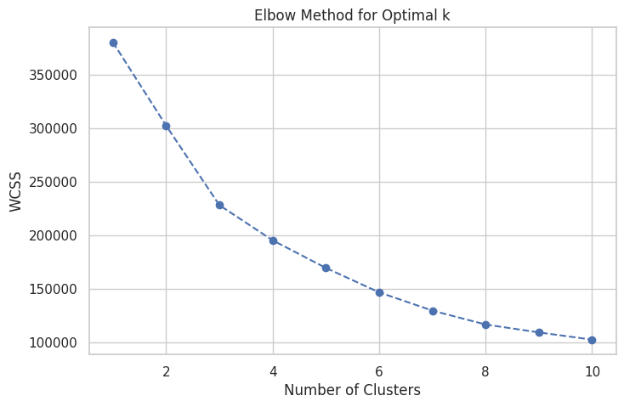
The plot (Figure 1) suggests that an optimal cluster size is around k = 3, where the rate of decline in WCSS starts to flatten.
Using the K-Means algorithm with k=3, we grouped the products into clusters. After running the model, we obtained the following cluster distribution:
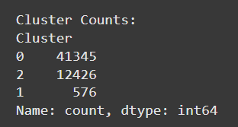
Cluster 0: 41,345 products, Cluster 1: 576 products, and Cluster 2: 12,426 products. This distribution indicates that most products fall into one dominant category, with one cluster representing a much smaller subset of items. To better understand the cluster separation, we performed Principal Component Analysis (PCA) to reduce the feature space to two dimensions. The PCA-transformed clusters were visualized using a scatter plot.
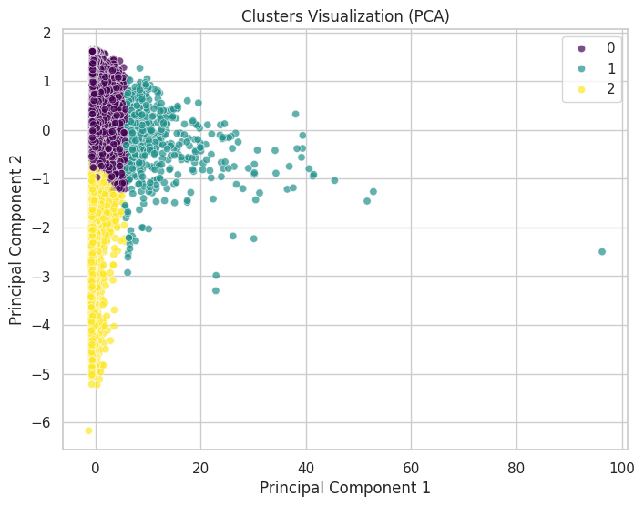

This visualization highlights how the clusters are distributed in the reduced feature space, with some clear separation among them.
To further explore what differentiates these clusters, we calculated the mean values for key numerical features within each group and visualized them using a heatmap.
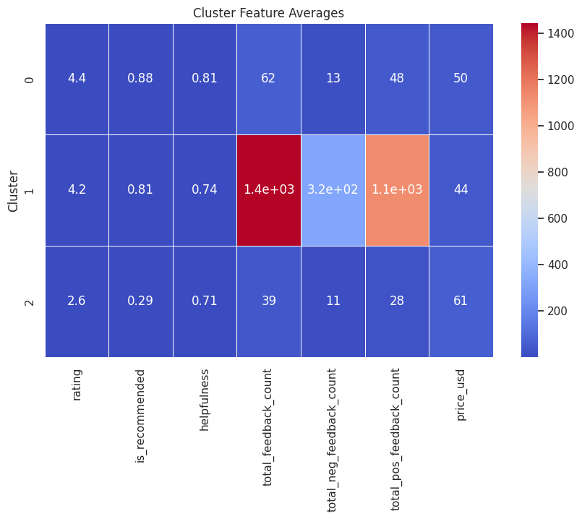
This lab successfully applied K-Means clustering to segment products based on user engagement and feedback characteristics, uncovering key differences in product ratings, pricing, and customer satisfaction. One of the most significant takeaways was recognizing how certain clusters contained products with significantly higher negative feedback, indicating potential quality or expectation issues. Additionally, the strong separation of clusters in the PCA visualization suggests that user interactions and product pricing play distinct roles in defining these groups.
Currently, my project has transitioned from descriptive analytics to unsupervised learning, allowing me to move beyond summary statistics and into meaningful pattern detection within the dataset. This clustering analysis has set the stage for more complex machine learning techniques. In Lab 5, I can further refine the clustering process by testing alternative algorithms like Hierarchical Clustering or DBSCAN to see if different approaches yield more insightful groupings. Additionally, integrating categorical variables such as brand name, skin type, or eye color through encoding methods could enhance cluster interpretability. Another potential next step is incorporating supervised learning models to predict user engagement or product success based on cluster membership. By implementing these techniques, I will continue developing a more advanced and actionable understanding of product performance within the dataset.

